**Setup Prometheus Monitoring On Kubernetes Cluster**

1. Creating the namespace and cluster

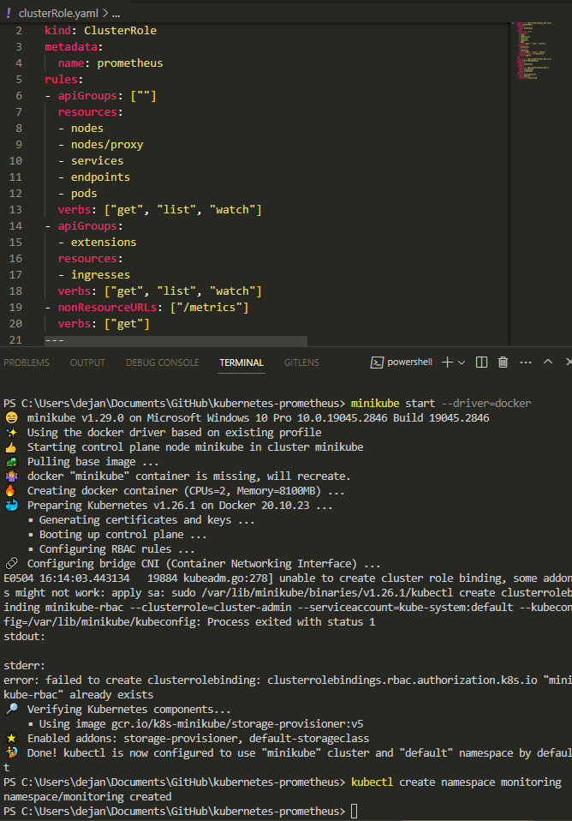



1. Configuring the map in Kubernetes

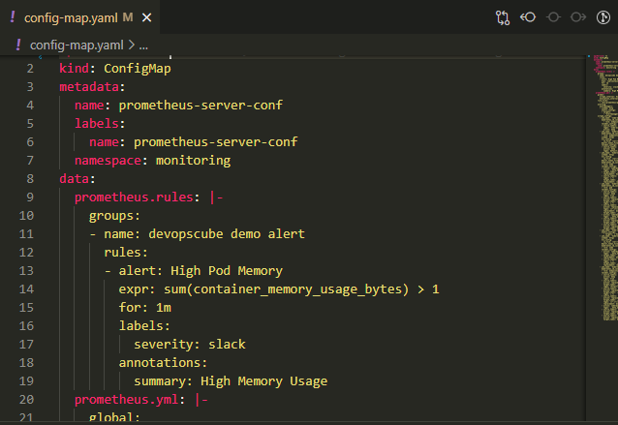



1. Creating prometheus deployment

As we can see there are new and modified files in the container

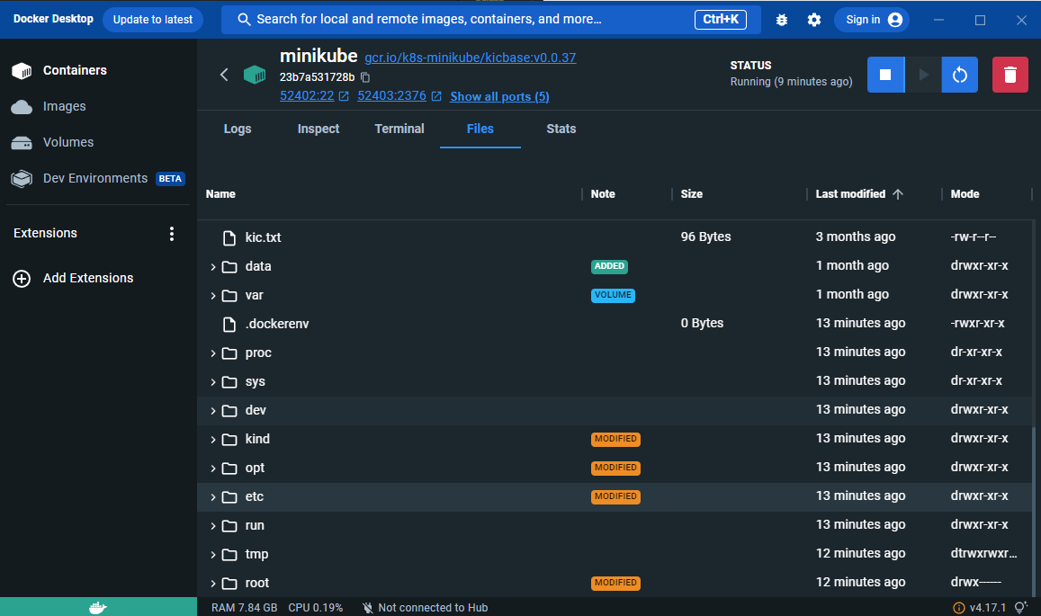



Checking if the Prometheus deployment is running

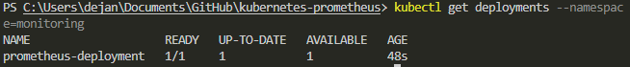

1. Port forwading the prometheus pod

As you can see I had issues with the port forwading but I managed to fix it by changing the port from 8080 to 5000

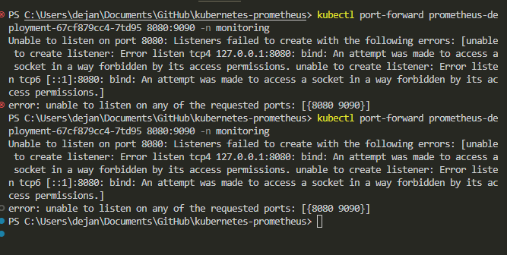

Here is the change of the port and the command

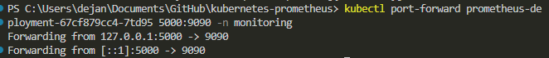

1. Here is the Prometheus dashboard

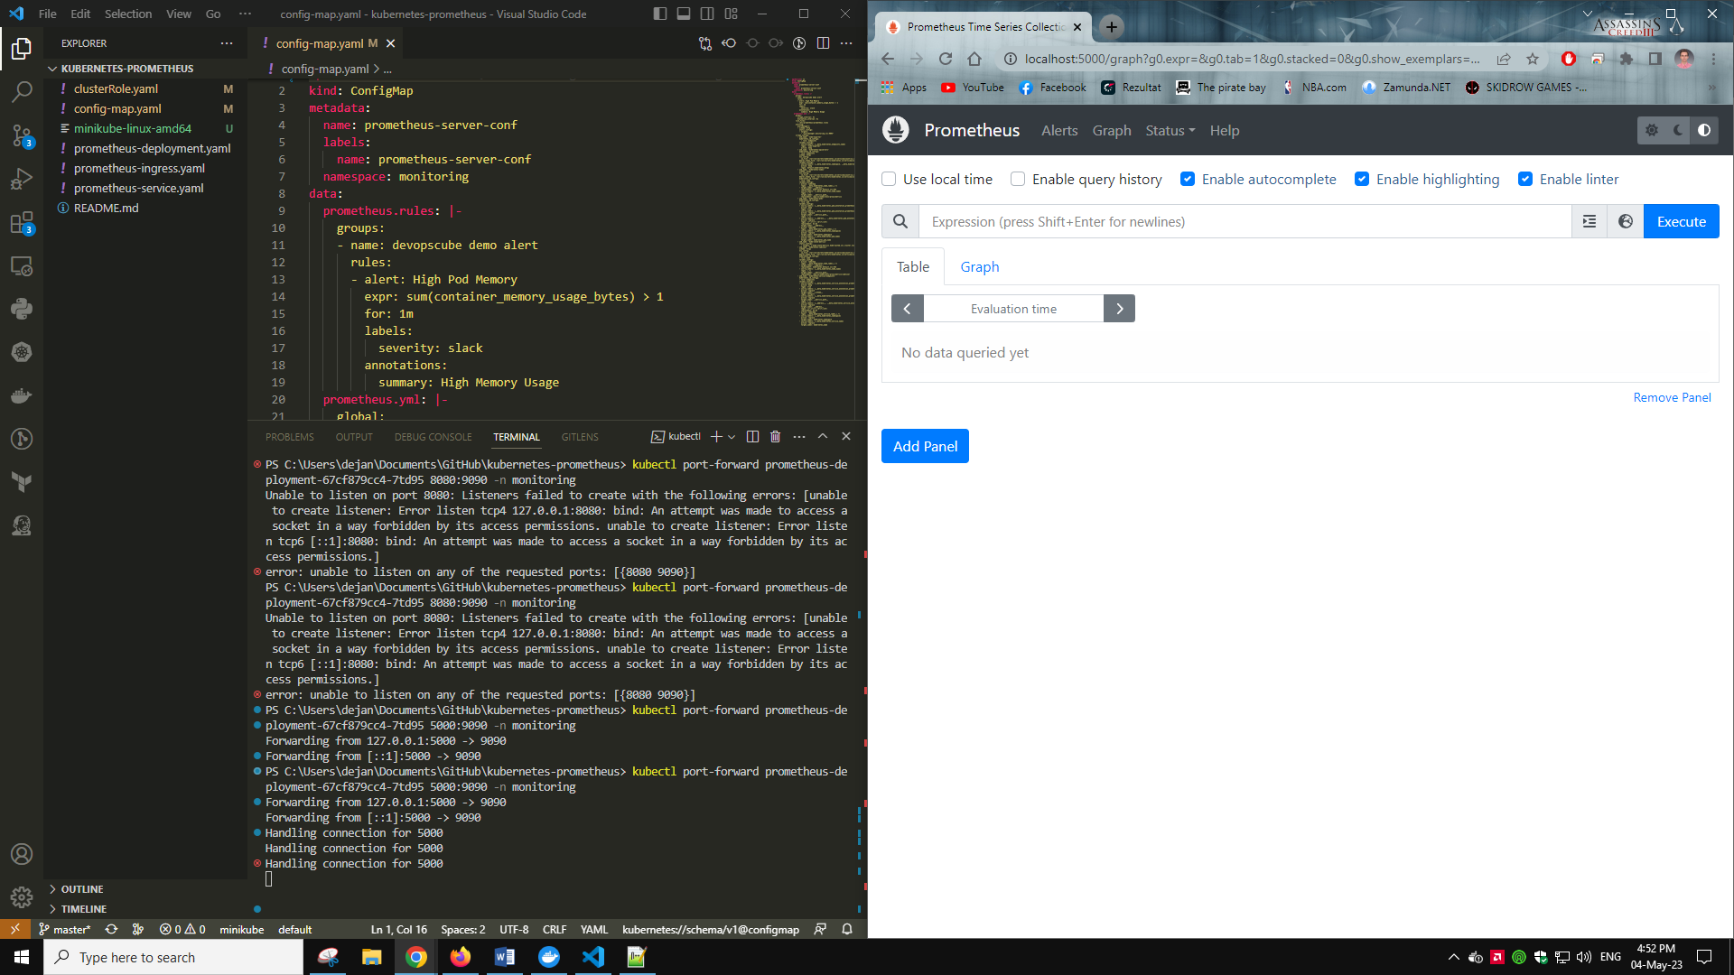

1. Here see all the Kubernetes endpoints connected to Prometheus automatically using service discovery

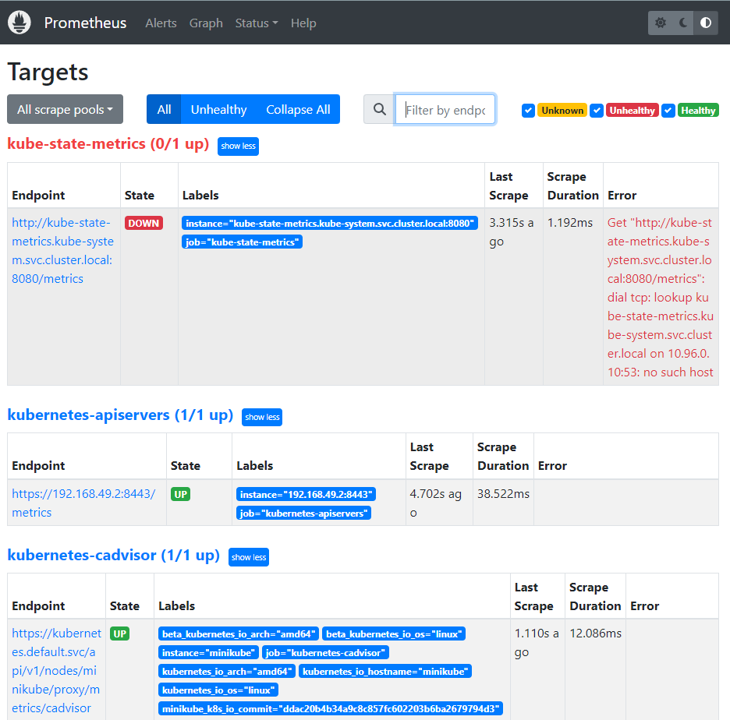

1. Here we can see the graph of cpu usage in seconds

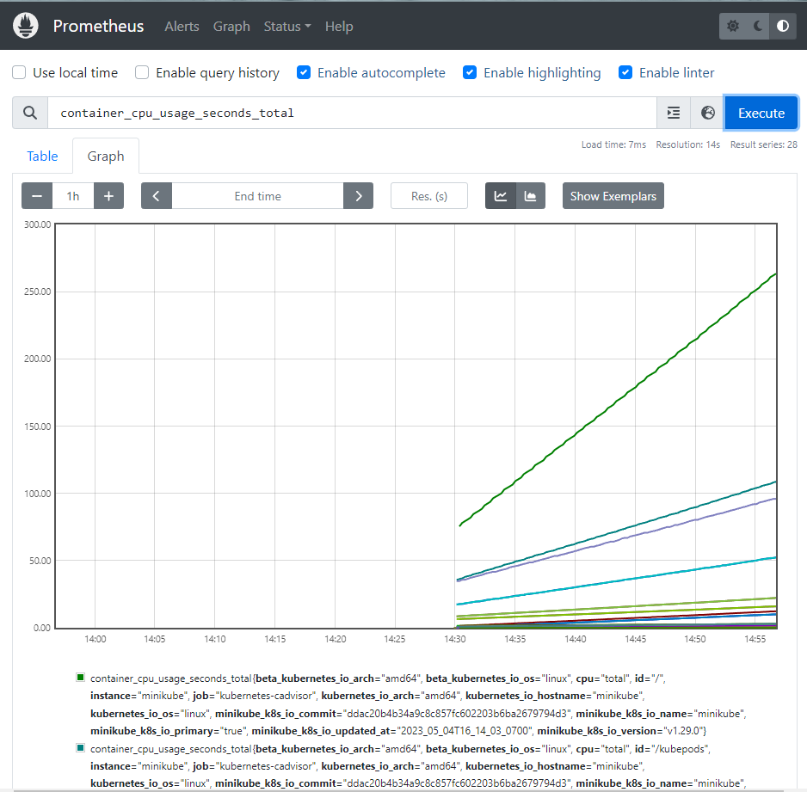

1. Here we are setting up a grafana source





1. Once we setup the deployment yaml file with the appropriate ports we open grafana and we log in

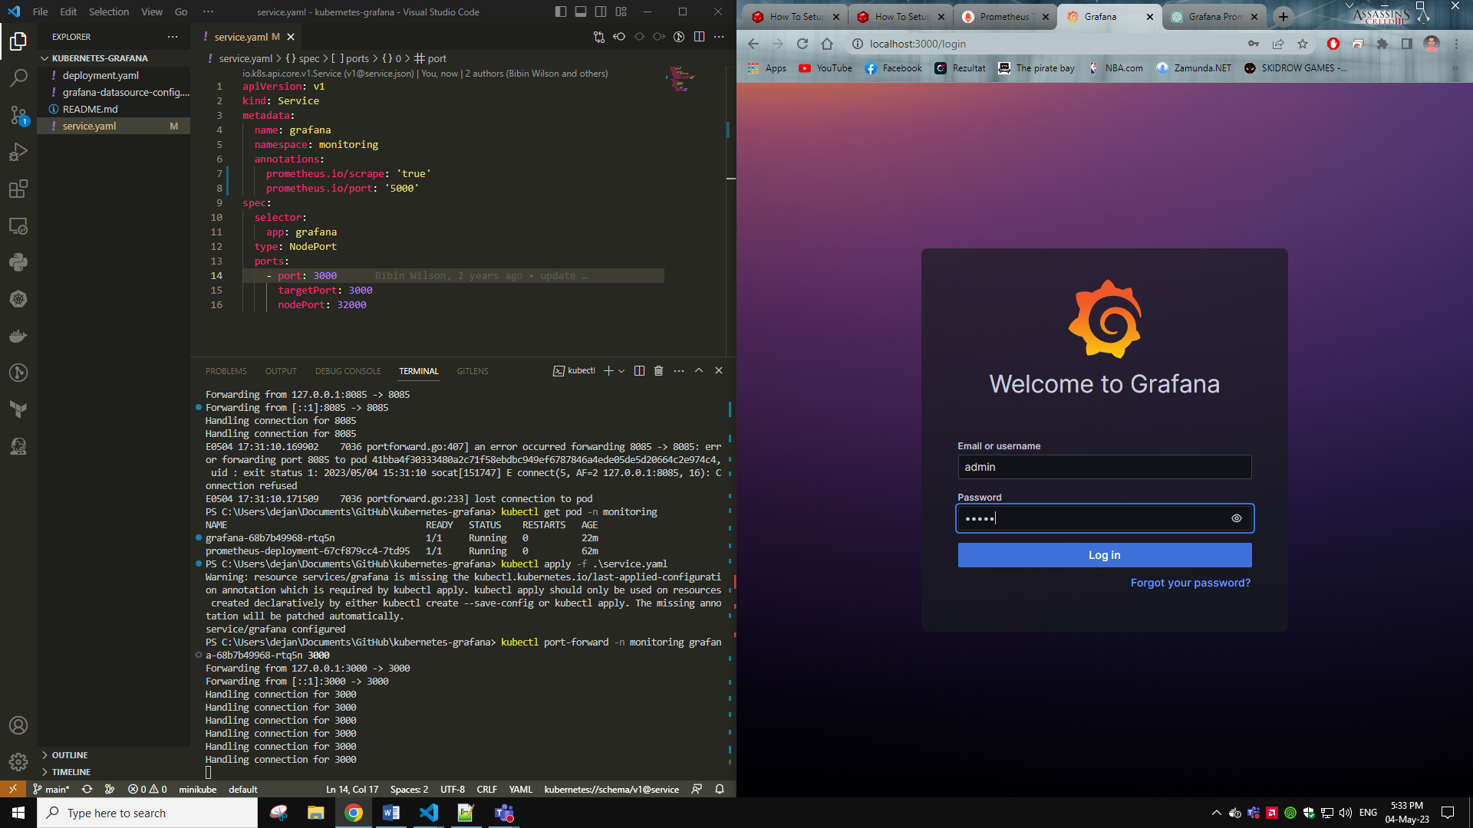

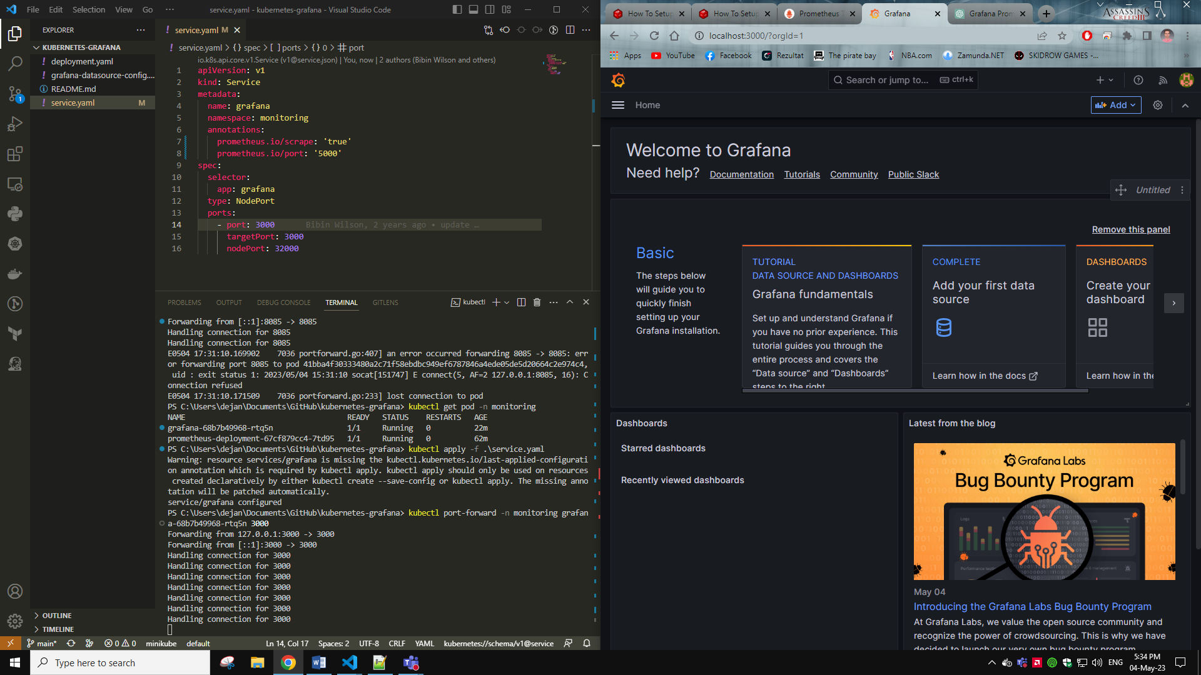

1. After that we setup a dashboard on grafana but for me it didn’t work at first and had to change the ip and ports in order to work

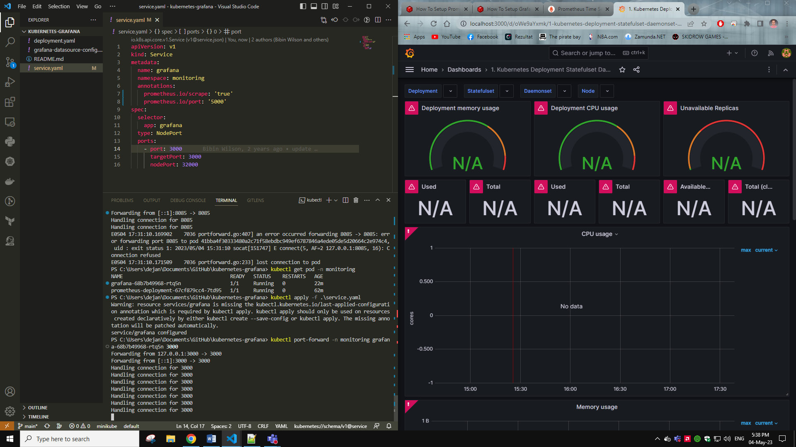

1. After the fix grafana dashboard works correctly

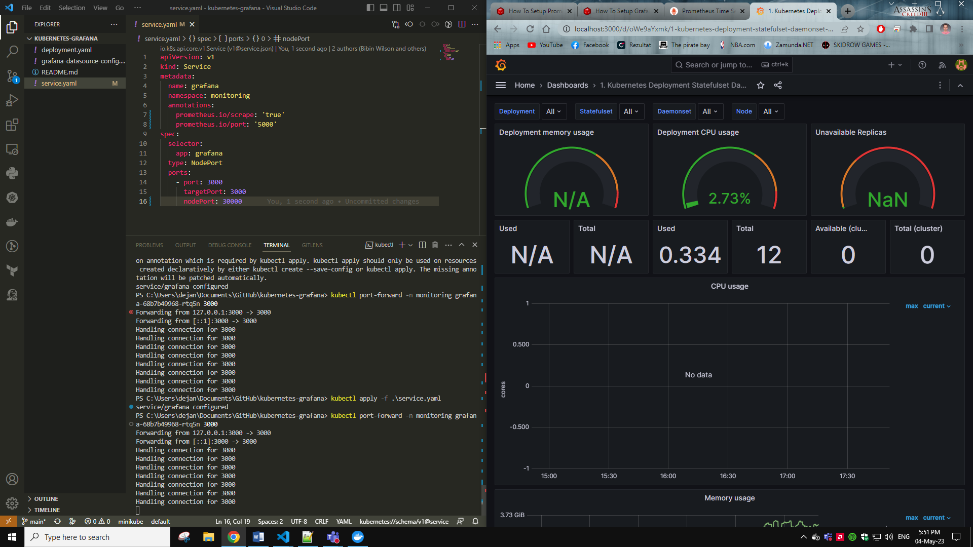

<https://devopscube.com/setup-prometheus-monitoring-on-kubernetes/>